Below are SQL codes and query output for the eight (8) assigned tasks.

-- 1. List the following details of each employee: employee number, last name, first name, gender, and salary.

select e.emp_no, e.last_name, e.first_name, e.gender, s.salary

from employees AS e

left join salaries AS s

on s.emp_no = e.emp_no;

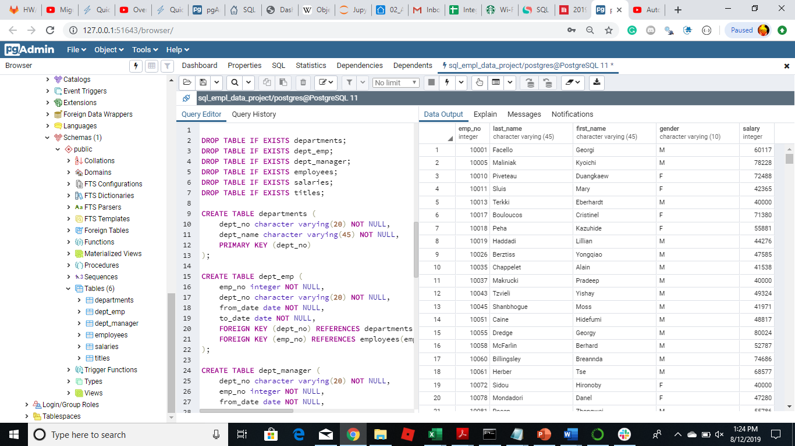

-- 2. List employees who were hired in 1986.

SELECT *

FROM employees

WHERE hire_date::TEXT LIKE '1986%';

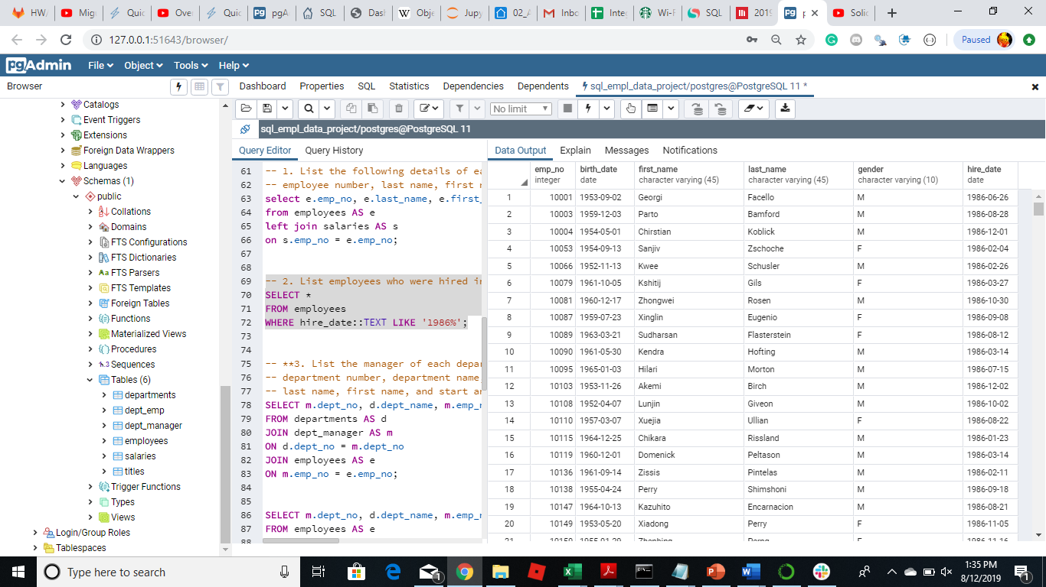

-- **3. List the manager of each department with the following information: department number, department name, the manager's employee number, last name, first name, and start and end employment dates.

SELECT m.dept_no, d.dept_name, m.emp_no, e.last_name, e.first_name, m.from_date, m.to_date

FROM departments AS d

JOIN dept_manager AS m

ON d.dept_no = m.dept_no

JOIN employees AS e

ON m.emp_no = e.emp_no;

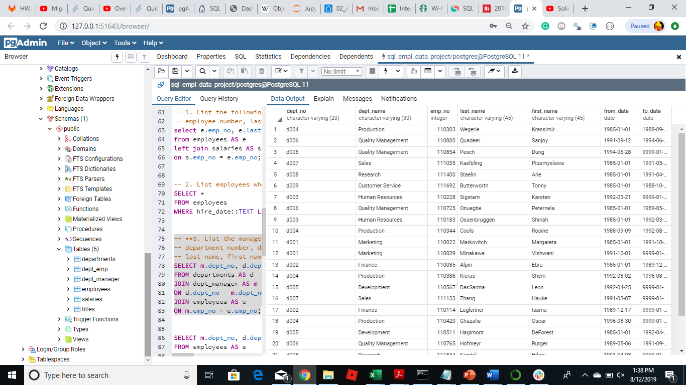

ALTERNATE OR OPTIONAL SQL CODE, PROVIDED SAME RESULTS:

SELECT m.dept_no, d.dept_name, m.emp_no, e.last_name, e.first_name, m.from_date, m.to_date

FROM employees AS e

JOIN dept_manager AS m

ON m.emp_no = e.emp_no

JOIN departments AS d

ON d.dept_no = m.dept_no;

-- 4. List the department of each employee with the following information: employee number, last name, first name, and department name.

SELECT e.emp_no, e.last_name, e.first_name, t.dept_name

FROM employees AS e

JOIN dept_emp AS d

ON e.emp_no = d.emp_no

JOIN departments AS t

ON t.dept_no = d.dept_no;

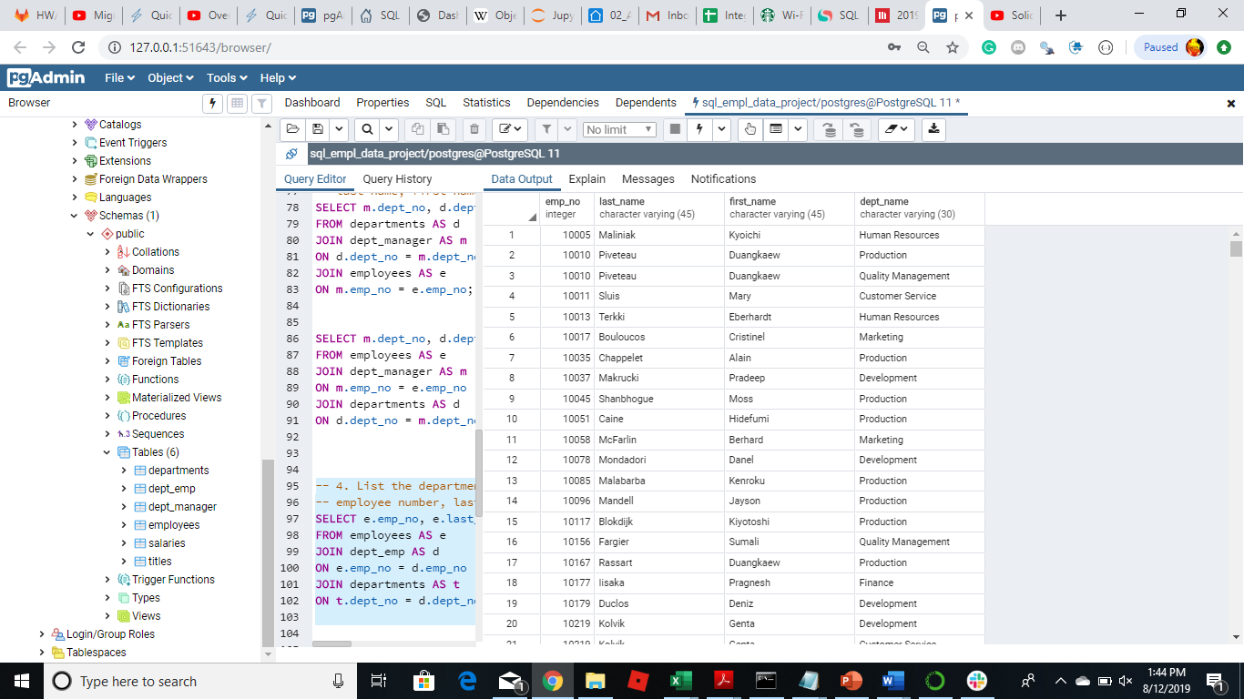

-- 5. List all employees whose first name is "Hercules" and

-- last names begin with "B."

SELECT first_name, last_name

FROM employees

WHERE first_name = 'Hercules' AND last_name::TEXT LIKE 'B%';

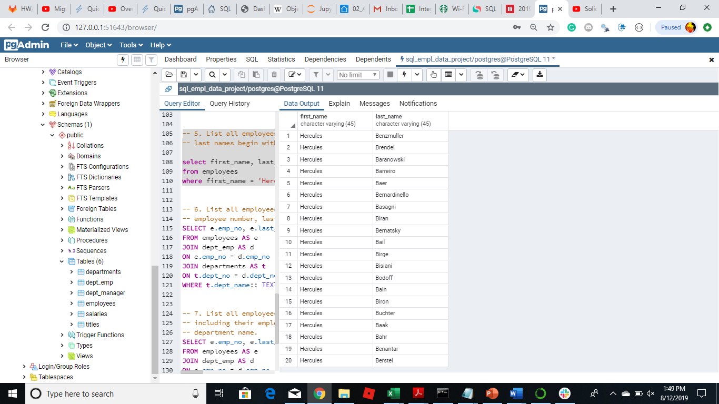

-- 6. List all employees in the Sales department, including their employee number, last name, first name, and department name.

SELECT e.emp_no, e.last_name, e.first_name, t.dept_name

FROM employees AS e

JOIN dept_emp AS d

ON e.emp_no = d.emp_no

JOIN departments AS t

ON t.dept_no = d.dept_no

WHERE t.dept_name:: TEXT LIKE 'Sales';

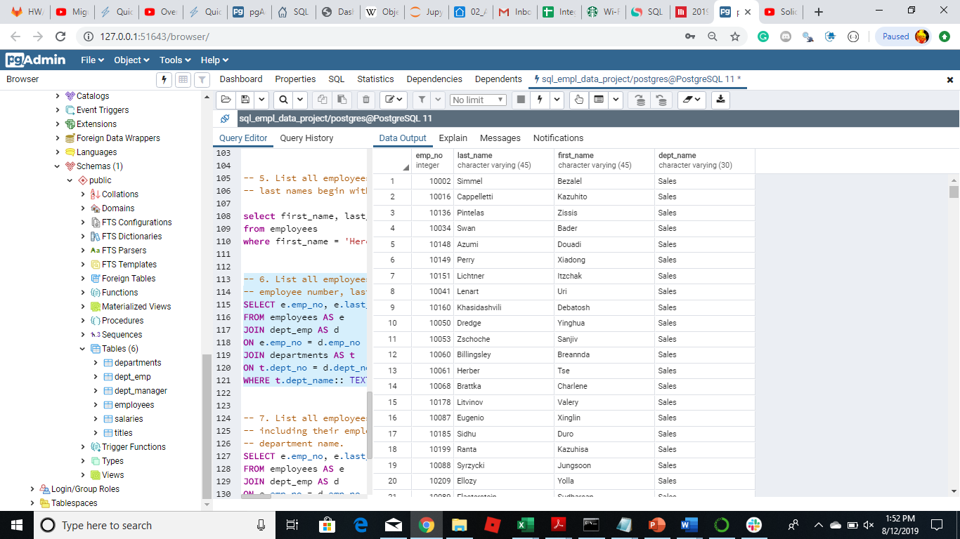

-- 7. List all employees in the Sales and Development departments, including their employee number, last name, first name, and department name.

SELECT e.emp_no, e.last_name, e.first_name, t.dept_name

FROM employees AS e

JOIN dept_emp AS d

ON e.emp_no = d.emp_no

JOIN departments AS t

ON t.dept_no = d.dept_no

WHERE t.dept_name:: TEXT LIKE 'Sales' OR t.dept_name:: TEXT LIKE 'Development' AND t.dept_name:: TEXT LIKE 'Development';

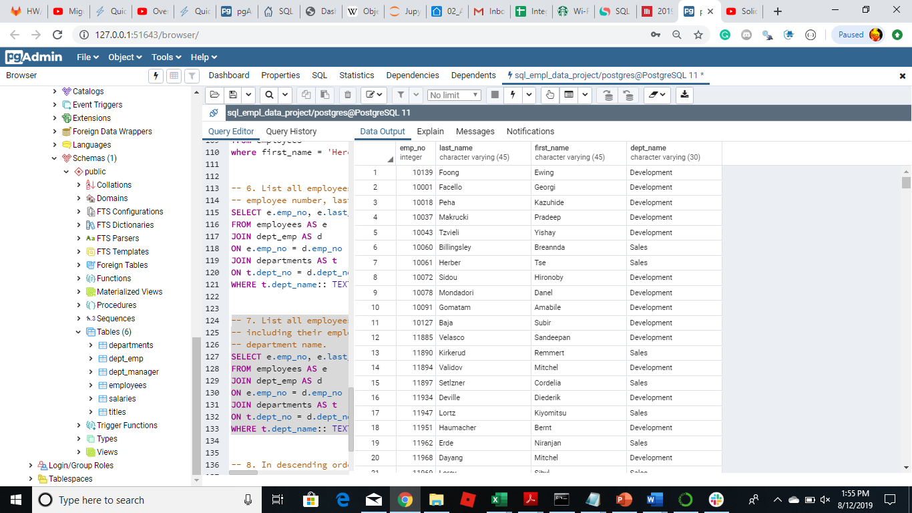

-- 8. In descending order, list the frequency count of employee last names, i.e., how many employees share each last name.

SELECT last_name, COUNT (last_name) AS "Last name counts"

From employees

GROUP BY last_name

ORDER BY "last_name" DESC;

